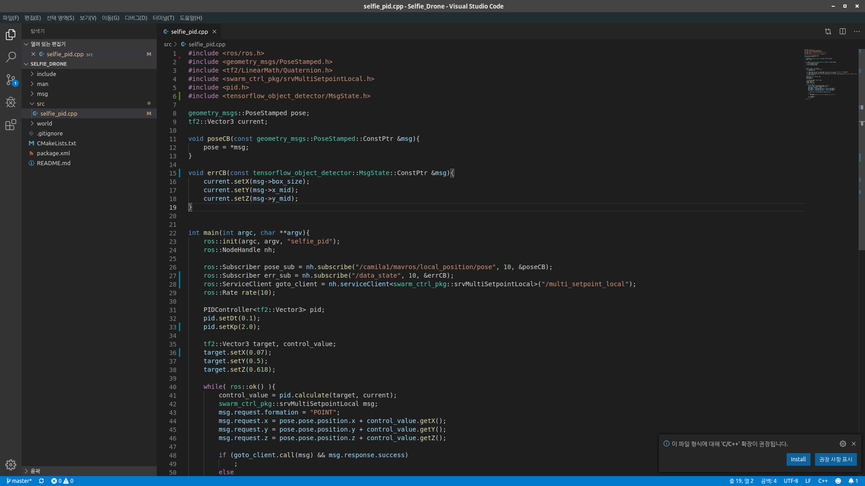

#include <tensorflow_object_detector/MsgState.h>

ros::Subscriber err_sub = nh.subscribe("/data_state", 10, &errCB);

